Managing Job Advertising
Objective
After completing this lesson, you will be able to set up and utilize job posting contracts to optimize job advertising strategy.
Job Advertising in SmartRecruiters
Effectively advertising job postings is crucial for attracting the right talent. SmartRecruiters offers several features to streamline this process, including the ability to manage job board contracts and automate job distribution.
Job advertising is a critical component of the recruiting process. After publishing a role publicly in SmartRecruiters, you can advertise it on various job boards. SmartRecruiters allows you to purchase ad-hoc job postings and, if you have the Job Distribution module, integrate your existing job board contracts.
Free Job Board Aggregators
When creating a Job with a publicly published Job Ad, a user can select if the Job Ad is also published to Job Board Aggregators. The user is also able to select which aggregators the ad is published to.
It is valuable for the users to monitor the volume and quality of each source to ensure the recruitment team a manageable volume of high-quality applications.
Here's a full list of the free job aggregators that SmartRecruiters will post your job ads to.
- AboutJobs.com
- Adzuna
- Careerjet
- CVLibrary
- Cleverism.com
- Crunchbase
- Flexjobs (Free listing)
- Glassdoor (Free listing)
Note
Distribution to Glassdoor works throughout the common integration with Indeed which means that publishing ads to Indeed also sends them to Glassdoor.
- Indeed
- JobInventory
- JobRapido
- Jooble
- JuJu.com
- LinkedIn (Limited Listing)
- Monster Controlled Listings
- OfferUp
- Talent.com - formerly Neuvoo
- Resume-Library
- Trovit
- Way Up
- ZipRecruiter
Buy Job Advertising
When using the Create Job wizard, a user has two options to select and pay for specific job advertising.
Steps
- Select the Job board marketplace tab. After creating the job, the system will take you to the advertise screen, Job board marketplace tab.
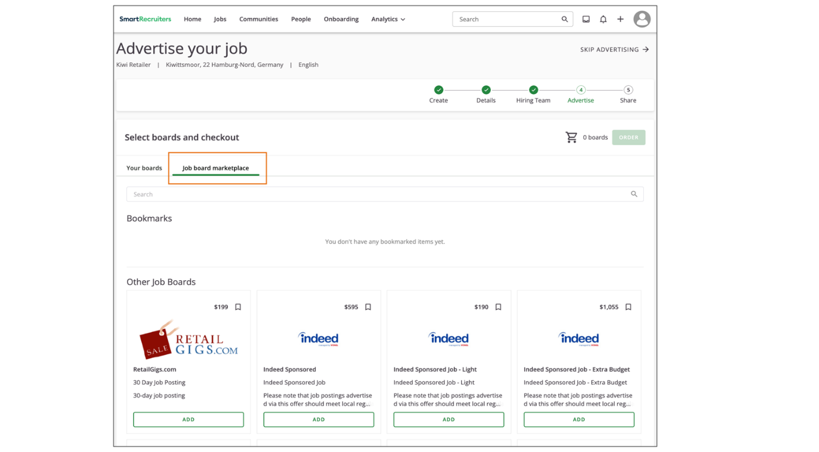
- Select the Advertise button when accessing a job after its creation. This allows a user to purchase advertising without an ongoing contract with that job board.
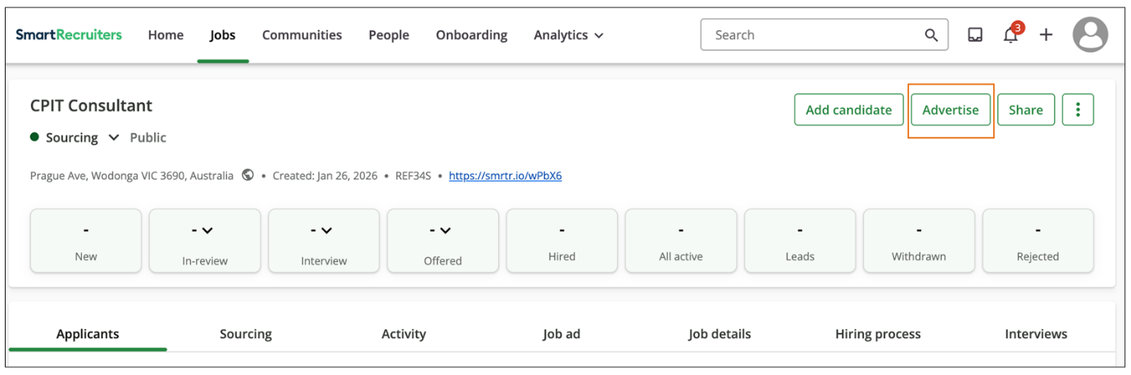
Set Up Job Posting Contracts for LinkedIn
All customers can use their existing LinkedIn contracts to post jobs without the Job Distribution module. You can easily manage your job posting contracts under Settings in the Job Advertising area.
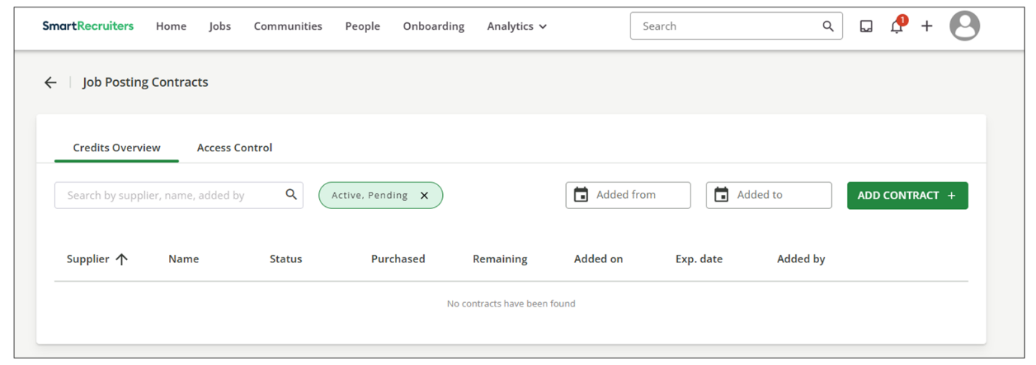
Adding a LinkedIn contract when a customer has the Job Distribution Module:
Steps
- Navigate to Job Posting Contracts.
- Select the option to add a new contract.
- Start typing LinkedIn in the job board search field.
- Select LinkedIn from the options.
- Enter the required information, including the contract name, ID, company ID, expiration date, and price per post or credit. This information helps track hiring costs.
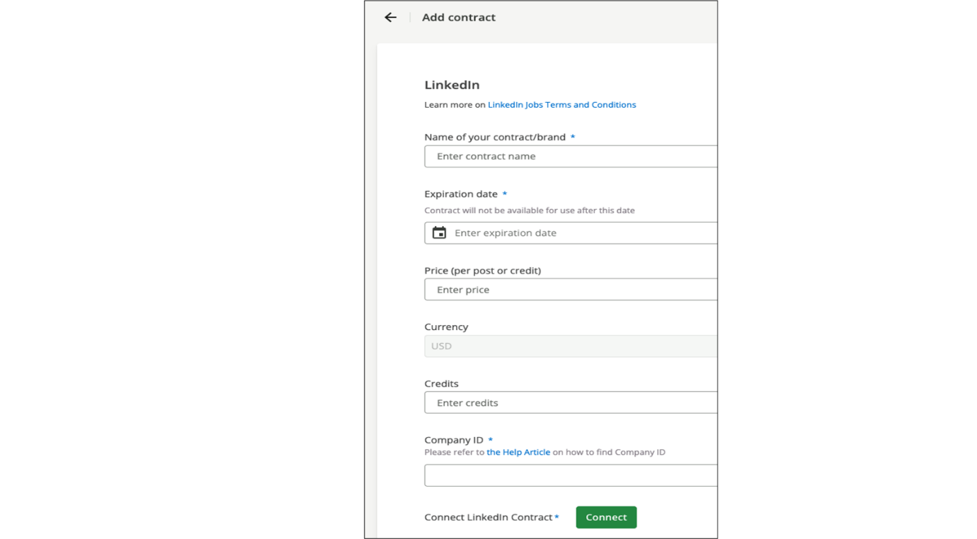
Job Distribution Overview
Job Distribution allows customers to benefit from intelligent technology to gain access to a large portfolio of job boards to easily distribute high quality ads to the job boards they trust to find the right candidates for their open positions.
To leverage a more automated and intelligent solution, SmartRecruiters has integrated a multi-posting solution that allows our customers to leverage more automated feeds, via XML and API, to post their jobs to desired job boards.
Add a Job Board with Job Distribution
For Job Distribution users, adding other job board contracts follows a similar process to adding LinkedIn to the Job Posting Contracts page. For example, to add a Total Jobs contract:
Steps
- Navigate to Job Posting Contracts.
- Select the option to add a new contract.
- Type Total Jobs in the job board search field.
- Enter the required information (Contract Name, Company Name, Expiration Date).
- Save the contract.
Result
The SmartRecruiters Marketplace team will then set up the contract, making it available for posting jobs from the Create Job wizard or directly from the list of published jobs.
SmartJobs Overview
SmartJobs is a managed service that helps recruiters utilize a new method of job advertising. This offers intelligent and centralized job advertising using programmatic technology in order to reach the right audiences at the right time. Unlike traditional advertising with set budgets and single postings, SmartJobs enables users to advertise jobs in bulk, to a variety of vendors from one standpoint, depending on your current hiring goals and needs.
Recruiting organizations will simply need to set a budget, define the top-priority jobs using flexible rules and the rest will be pulled directly from the SmartRecruiters Career Page and onto Sourcing Analytics.
Benefits of SmartJobs
- Only pay for performance: The buying method is CPA (Cost-Per-Application)
- Intelligent budgeting
- Increased reach to an extensive network of job boards, aggregators and niche websites
- Versatile audiences
- Fully automated
- Seamless Integration with SmartRecruiters' API
- View the results and performance directly in your Sourcing Analytics
Automate Job Distribution
SmartRecruiters offers Automated Job Distribution, a feature that automatically posts job ads to specific contracts, eliminating the need for manual posting.
To set up automated job distribution:
Steps
- Navigate to the Automated Job Distribution section.
- Create a new rule and provide a description (e.g., "Project Manager jobs in the UK posted to LinkedIn").
- Define the criteria for automatic posting using organization fields. For example, you can specify that if the country is the United Kingdom and the department is Marketing, the job should be posted to a specific LinkedIn contract.
- Select the contract you want to use for these jobs.
Result
This feature ensures that jobs are posted automatically, saving time and effort.
Summary
- Job posting contracts can be managed in the Admin settings, allowing you to integrate existing contracts and track hiring costs.
- Automated Job Distribution, available with SmartDistribute, allows you to automatically post jobs based on predefined rules.

Working with Recruiting Agencies and Candidates
Objective
After completing this lesson, you will be able to manage external recruiting agencies within SmartRecruiters.
External Agency Candidate Integration
Streamlining the recruitment process ​sometimes ​​​involves collaborating with external agencies. SmartRecruiters allows you to easily integrate external recruitment agencies into your hiring process. This integration streamlines candidate submissions and centralizes all candidate information within the platform.
SmartRecruiters simplifies this process by allowing you to easily manage and invite agencies to submit candidates directly into your system. This eliminates the need for emailed CVs and centralizes candidate information.
Note
Agency functionality may change based on business decisions and product enhancements.
Send and Assign Jobs to Agencies
If you have external recruiters or third-party agencies you want to work with, you can set them up in SmartRecruiters to receive job information and submit candidates directly. Instead of receiving CVs via email, the agencies can submit candidates through their recruiter portal.
Steps
- Sending a job to an agency.
  - Navigate to your list of jobs: For any publicly advertised job, you'll see the option Send to Agency. You can also find this option within the job itself, in the top right-hand corner of the screen.
  - Select Invite an Agency: Once in the Send to Agency area, you can send the job to agencies already set up in the system.
  - Provide basic information:
    - Agency Name
    - Contact Person at the Agency
    - Contact Email Address
After completing this information and sending the invite, the agency will receive an email asking them to register. Once registered, your team will receive a notification within 48 hours, indicating that the agency is set up and ready to use.
- Assigning a job to an agency.
  - Select the agency.
  - Add any relevant information you want to send.
  - Assign the job. This makes the job available to the agency in their portal.
In the Send to Agency area, you can easily see the status of each job assignment:
  - Whether the job is currently assigned to an agency.
  - The name of the assigned agency.
  - The agency's logo (if they've added one).
  - The contact person at the agency.
  - The date you last used the agency.
Agency User Experience
When agencies log in to SmartRecruiters, they'll see their dashboard. On the Home tab, they'll find an overview of their current workload, access to their company profile, offer management tools, Help Center articles, and an activity feed.
From the Assignments tab, agencies can view all active jobs assigned to them. They can select a job to see the details, including the company description and job advertisement information.
Once submitted, the agency can track their candidates from the People tab, which shows the number of submitted candidates, active candidates (those in offer, interview, or new status), and rejected candidates.
To submit a candidate, the agency selects Submit Candidate and fills out the required information:
- Upload the candidate's CV (drag-and-drop).
- Complete any missing candidate information.
- Provide a rating and review for the candidate.
- Add any other helpful information for your review.
Agency Candidate Identification
Back in your SmartRecruiters system, it's easy to identify candidates submitted by agencies. When viewing a candidate's profile, the source information in the top right corner indicates which agency submitted them.
Gain more knowledge about working with agencies by watching the video below.
This video is for demonstration purposes. Any references made in this video to previous or later videos in this course (including titles, numbers, links, or sequence) may differ from the current course structure. Additionally, some functionalities shown may have evolved over time due to ongoing enhancements or business decisions.
Summary
- Inviting Agencies: SmartRecruiters allows you to invite external agencies by providing their name, contact person, and email address, streamlining the setup process.
- Assigning Jobs: You can easily assign jobs to agencies through the Send to Agency feature, making job details available in their portal.
- Agency Submission Process: Agencies can submit candidates directly through their portal, including CV uploads, candidate information, and ratings.
In this video, we're going to
review how to send jobs and communications to agencies using the
Agency Portal in SmartRecruiters. To send a job to an agency, navigate
to the job you want to send, and then click the Add External Agency
button at the top right of the page. On the Agency page, you'll see a
list of your agencies along with their contract, working type,
fee structure, and agency rating. Agencies that have accepted
the agency portal invite and contract will be automatically
selected to receive the job, while agencies that have a
pending invitation will not. Accepted agencies will
have a checkmark icon, and pending agencies
will have a clock icon. You can still send jobs to
pending agencies, but they won't be able to see the
job in their portal until they have accepted the
invitation and contract terms. If you want to send a job to a
list of agencies, you can select the list from the agency list
drop down and click the Add button. This will select all the
agencies within the chosen list, or you can filter agencies by clicking the filter icon in the lists column. If you need to send a message to
all the agencies working with the job, you can click the Broadcast
Message button. And what this allows you to do is share job updates with
all of those agencies with one message, rather than having
to message each agency separately. For example, if there was a
salary change or deadline updates, you can quickly type your
message and send it to all agencies with one click, where
they can view it in their agency portals. You will also be able
to view the dates of the last five messages you've sent, as
well as the message content. You can preview how your job will
appear to agencies in their portal by clicking the View Agency Job
button at the top left of the screen. Here you can share job details
and terms and add agency specific information that will only appear on
the private agency view and not on your career site. To edit or add
job information on this page, click any of the section edit icons and
then make your desired changes. When you're ready, click
the Save and Preview button and then on the main page
click the Publish button. Back on the agency's page on the
job you have the option to map the stages within your hiring process
to the application process stages in the Agency Portal. To do this
click the Agency Job Stages button at the top of the page and here you'll
see the current stage mappings. On the left are the steps
and stages within the hiring process and SmartRecruiters and on the right are the mapped process
stages in the Agency Portal. The agency stages of Introduced and
Offered are required to be mapped as well as at least one interview
stage and these stages will already be mapped for you by default.
To change a mapped stage click the Edit button next to the stage
and you will get a prompt explaining that if you have already sent
jobs to agencies changing the mapping may have an effect on the
movement of candidates already in the hiring process. To continue
editing click the I understand button and then you can select the stage
you want to map from the drop -down and when you're finished scroll
down and click the Save button. At the bottom of the mappings
page you can review when SmartRecruiters last sent
data to the Agency Portal. If you ever need to manually
refresh the data sync from SmartRecruiters
to the Agency Portal, you can do so by clicking the
Refresh ATS data button. Back on the agency page
you have the ability to add tags to this job
such as high priority, You also can put the job on
hold for agencies by clicking the Job on Hold button, and
once a job is ready to be resumed, click the button
again to make the job active. When you're ready to submit
your job to an agency, make sure to have the agencies you want to
send it to selected, and click the Confirm My Selection button
at the bottom of the page. Back on the job page,
you will be able to view candidates submitted by
agencies on the applicant list along with the rest of
the non-agency applicants. Candidates that are sent through
the agency portal are run through a duplicate check
that will block duplicate candidates from being added to
the same job based on their email address, phone number, name,
and LinkedIn profile URL. To filter by agency candidates,
you can click on the More Filter option at the
top of the applicant list, and under the Tags section,
select the Agency tag. In addition to the Agency
tag, the name of the agency and the agency fee are
also added as tags to the candidate's profile when
they are submitted to a job. As the candidate is moved to different
stages within the hiring process, the agency will be notified
automatically in their agency portal, eliminating the need for manually
sending candidate updates to the agency. The Agency Portal also allows
you to communicate with the agency directly in
SmartRecruiters. To send a message to the agency within
the candidate application, click the Communication tab and
then scroll down to the Agency Chat section. When you expand the
Agency Chat section, you'll see any correspondence sent between you and
the agency in regards to the candidate. When you send a message to the
agency, they will receive the message notification in their
agency portal, eliminating the need to send messages to an agency
outside of SmartRecruiters. You can also view agency
communications in your SmartRecruiters Inbox, located at
the top right of the screen. Once you're in your inbox,
click the My Inbox option on the left-hand side of the page
and then select Agency Inbox. Within the Agency
Inbox, you can view your agency list on the left
-hand side of the page. To message an agency, click
on the Agency and then you have the option to
either send a general message or you can send a message
about a particular candidate by selecting the
candidate from the list. If you are sending a message
about a candidate, any prior messages that were sent and
received from the candidate's application will also
display in the agency inbox, allowing you to seamlessly
continue the conversation. Thanks for watching this video on
how to send jobs and communications to agencies using the Agency
Portal in SmartRecruiters.

Managing Employee Referrals
Objective
After completing this lesson, you will be able to manage employee referrals.
Submit Employee Referrals in SmartRecruiters
Some of the best hires come ​through ​​high-quality ​referrals​ from existing employees​. SmartRecruiters' Referrals makes it easy for employees to submit referrals, and for hiring managers and recruiters to track and manage referrals.
There are two ways to get credit for your referrals​ from the Employee Portal​:
Steps
- Provide the referral’s information directly to a​n individual​ job:
  - Navigate to the Employee Portal.
  - Navigate to the job you want to refer to.
  - Select Refer a Friend and provide:
    - The candidate's first and last name, a valid email address.
    - Some kind of recommendation on their skills, or why ​you​'re a fan, and a description of your relationship to help the recruiter and/or hiring manager on the job to gauge how well you know the candidate. This description will show up on the candidate's profile.
Note
You don't ​need ​to provide a resume, but if you have their resume, you can also include it in the referral submission.
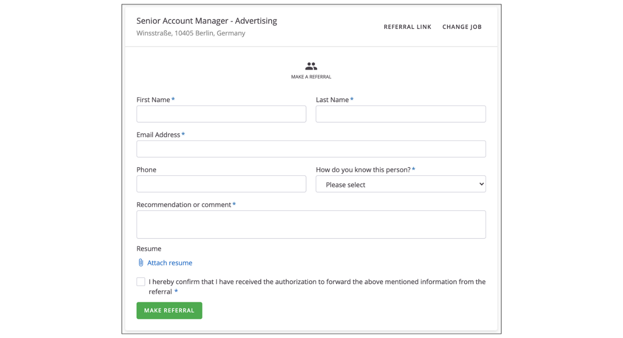
​​​The candidate will receive an invitation to complete their application and give their consent to store their data.​​
- Share the job ad. If you don't have a specific person in mind, or want to share the job and get credit for anyone who applies through that ad, follow these steps:
  - Navigate to the Employee Portal.
  - Select the job you want to refer to.
  - Select Referral Link to get a shareable URL for the job ad. The URL is unique to you. When someone applies to the job through this ad, SmartRecruiters will recognize the unique ID and attribute the referral to you.
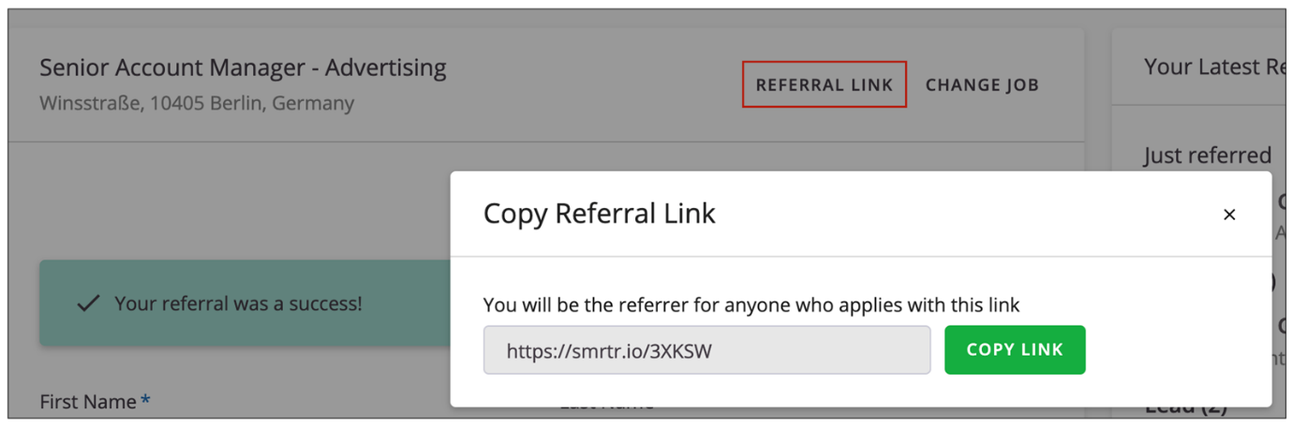
GDPR Retention Rules
SmartRecruiters offers administrators the ability to set up a GDPR Data Retention Rule. Upon request within the Company Compliance settings, if the candidate does not give their consent within 30 days, the profile will be automatically deleted.
This rule will now apply to referrals. When a user makes a referral in the system, a message is sent to the referred candidate, inviting them to officially apply and provide their consent, in line with the Company Compliance settings.
Employee Referrals Portal
​​​In the Referrals ​section of the Employee Portal​​, employees can easily submit referrals to specific jobs and monitor the progress of each referral through the hiring process. They can also get a unique link for sharing a specific job to get more approvals.
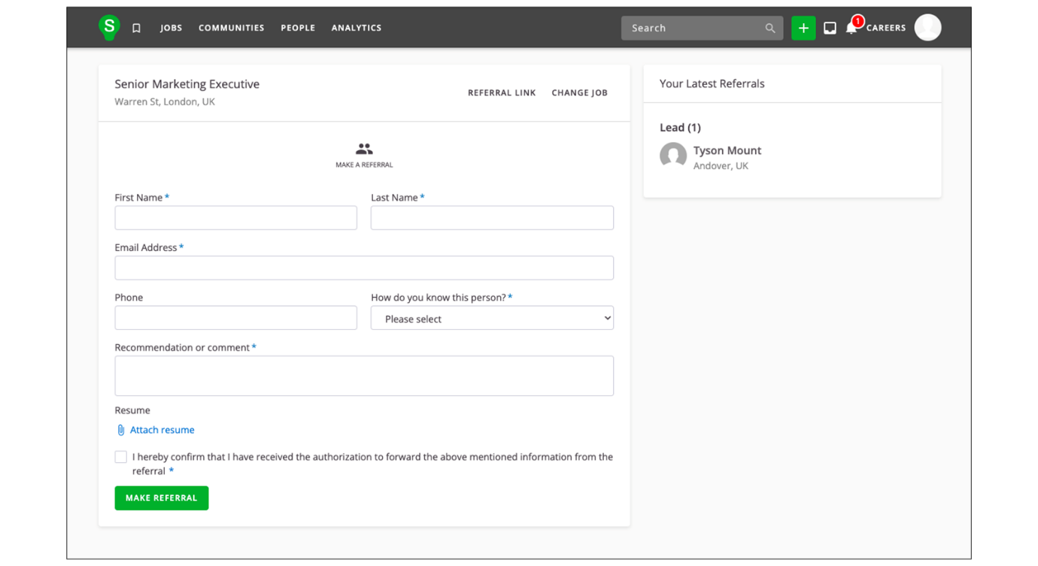
When someone submits a referral, SmartRecruiters emails the potential candidate for follow-up. Each referred candidate is added as a lead and marked with their referrer's name. The candidate can then apply on their own to become an active candidate for the job.
Referrals done through this method would show up on the sourcing page as:
- Source type = Referrals
- Source sub-type = Employee Referrals
- Source = [Referrer Name]
External Referral Form
You can also directly submit referrals from the job ad by selecting refer a friend, which will take you to a simple branded form.
The form consists of two parts:
- Information about the referral
- Information about the referrer
Referrals done through this method would show up on the sourcing page as:
- Source type = Referrals
- Source = [Referrer Name]
Note
The referrer’s last name and email address must match the record submitted by the referrer to be registered as a referral.
Referral Tracking
Recruiters and hiring managers can track job referrals on the Sourcing tab of the job page. Viewing the Applications by Source panel allows these hiring team members to see the total number of referrals for that job.
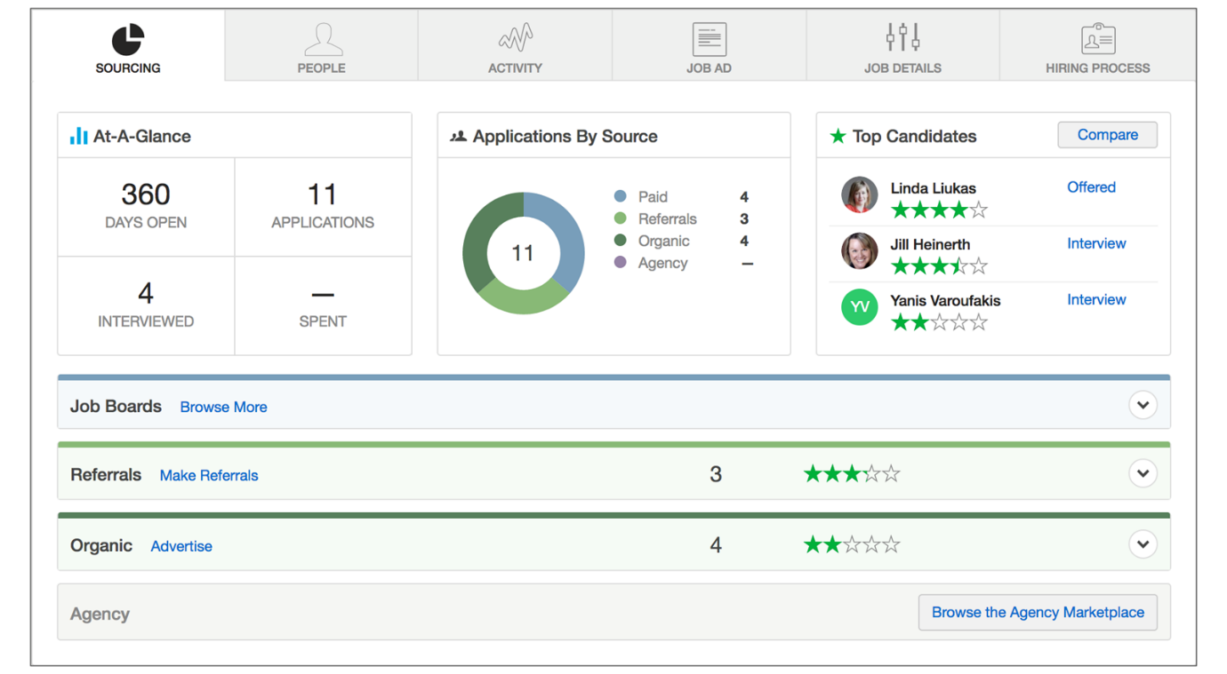
Within the Referrals panel, hiring team members can see the Leaderboard, which lists all referrers and the number of referrals they've provided for that job.
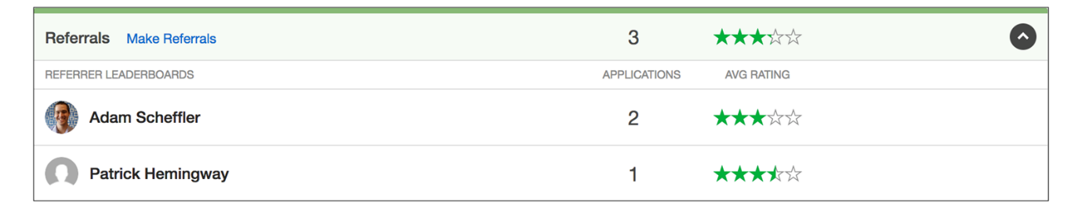
Note
You'll need full access to a job to see its Referrals leaderboard.
Employee Portal ​users
Employees who have submitted referrals before can monitor their referral status on the My Referrals page​ in the employee portal​.
To check on your referrals, open the user menu and select My Referrals.
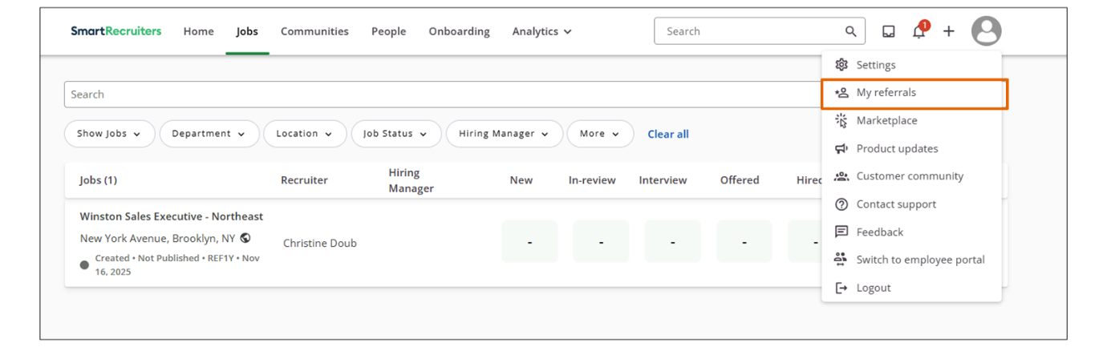
Employees can check the Your Referrals list for the status of each referral:
- Referrals in Just referred status haven't been reviewed yet
- Referrals with an In-review status are either:
  - An application in review
  - In the offer phase, but have not yet received or accepted an offer
- Referrals with an Interview status have a scheduled interview in the past or future
- Referrals with a Hired status got the job
- Referrals in the Not moving forward list wasn't a good fit, and wasn't chosen
- Referrals in the Other list are under consideration for another position. These candidates were referred to another position, and the hiring team for that role thought they might be a good fit for a different position.
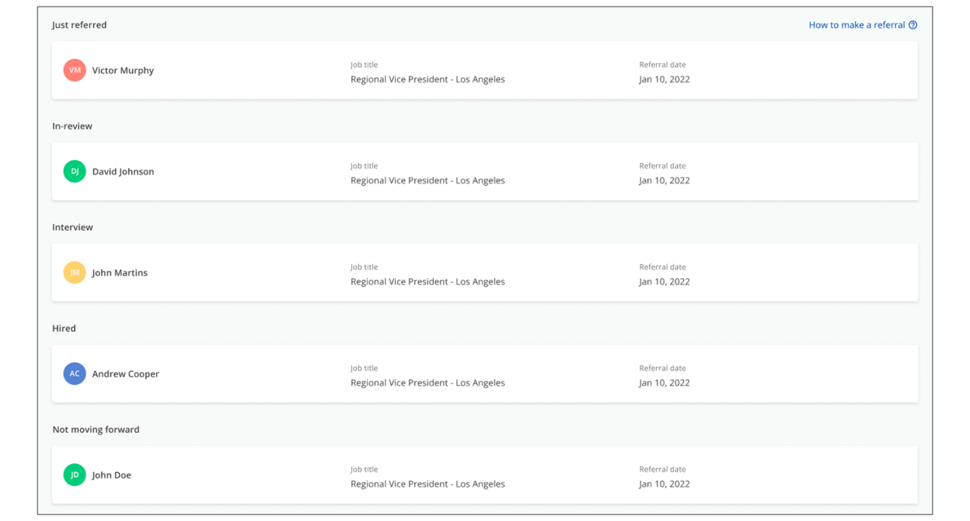
Summary
- SmartRecruiters' Referrals makes it easy for employees to submit referrals, and for hiring managers and recruiters to track and manage referrals.
- Employees can get credit for referrals by providing the referral's information directly to a job or by sharing the job ad using a unique referral link.
- SmartRecruiters offers administrators the ability to set up a GDPR Data Retention Rule for referrals.
- Employees can easily submit referrals to specific jobs and monitor the progress of each referral through the hiring process in the Referrals portal.
- Recruiters and hiring managers can track the referrals for a job on the Sourcing tab of the job page.
Setting Up Brands for the Career Site
Objective
After completing this lesson, you will be able to configure brand and logo assets to deliver a consistent, engaging candidate experience.
Candidate Experience Branding in SmartRecruiters
In today's competitive job market, a strong employer brand is crucial for attracting top talent. SmartRecruiters allows you to customize your branding to create a compelling candidate experience.
Within SmartRecruiters, you can manage your company's branding to create a consistent and engaging experience for job seekers. This includes customizing the look and feel of your job adverts and the candidate portal.
Custom Brands
Companies that manage multiple brands can easily create and configure each brand in SmartRecruiters with different logos, colors, and images.
Companies that can manage multiple brands can also set up specific configurations, such as a screening question set, email template, hiring process, or other feature, and assign them to one or more Brands using the Brand field.
Like other Org fields, Brands can be part of a dependent field configuration. Admins can also make the field required when a job is created.
Customize Your Default Brand
Every company that uses SmartRecruiters has at least one (default) Brand. Your default brand's logo is identical to the logo you add to your company profile. For companies with a single brand identity, all candidates will see the same branding.
To access your company's default logo(s) and information as an Admin:
Steps
- Navigate to Settings.
- In the Administration section, select Company Profile.
- SmartRecruiters allows you to add two versions of your default logo to the company profile and choose the best-fitting one when adding it to jobs, posts, and more.
- Select Choose a file for either the default or square logo to upload a new one.
- Select Save.
Note
The default brand name is pulled from your company profile and can only be updated by the SmartRecruiters Support team.
Customize Your Default Brand Settings
Steps
- Navigate to Settings.
- In the Configuration section, select Brands.
- To modify the default brand settings, select the pencil icon next to the default brand name.
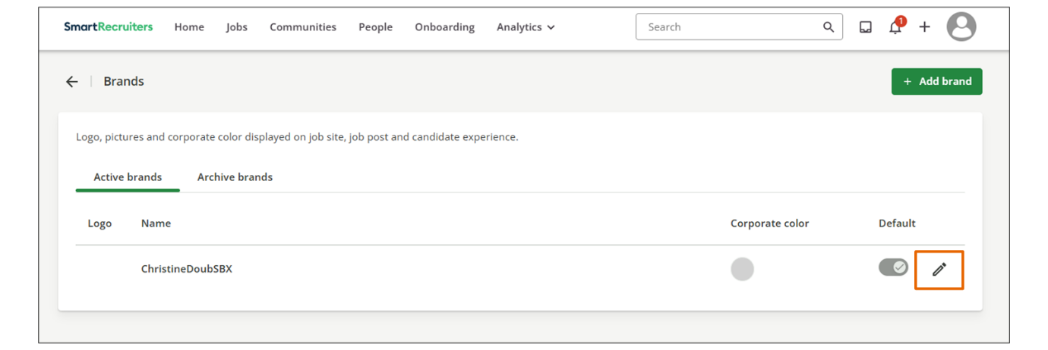
- Select the corporate color.
  - You can change your corporate color by entering the color code or by using the color selector. This color will be reflected in various elements of your job postings, creating a cohesive visual identity.
- Enter the brand website URL you want to direct candidates to
- Insert the LinkedIn Company page URL.
- Select the Brand Career Website.
  - Specify the careers website to which candidates should be directed when they select the Show all jobs link on a job advert.
  - If you're using your own careers process, update the custom URL to direct candidates to your main careers page. Otherwise, you can leave it set to the default SmartRecruiters hosted pages. This ensures that candidates are directed to the appropriate location based on your recruitment workflow.
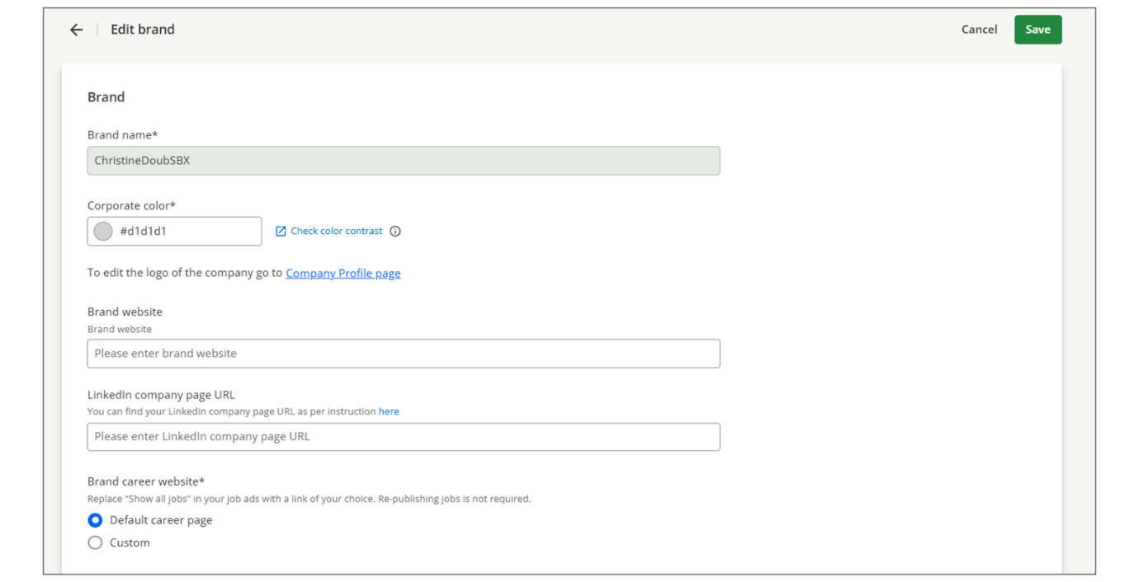
- Select the Job Page button color.
  - You can choose to use the same color as your corporate color or a different color. A strategically chosen button color can improve click-through rates and encourage candidates to take the desired action.
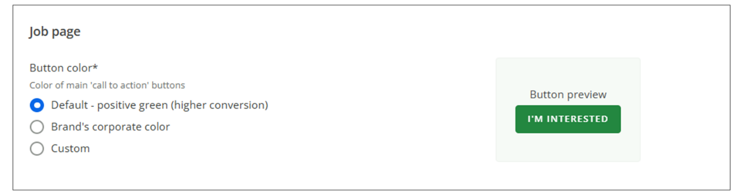
- Upload a header image.
  - You have the option to upload a header image and an office picture that will be used within the candidate portal. The header image appears at the top of the screen, and the office picture appears at the bottom, creating a visually appealing and branded experience for candidates.
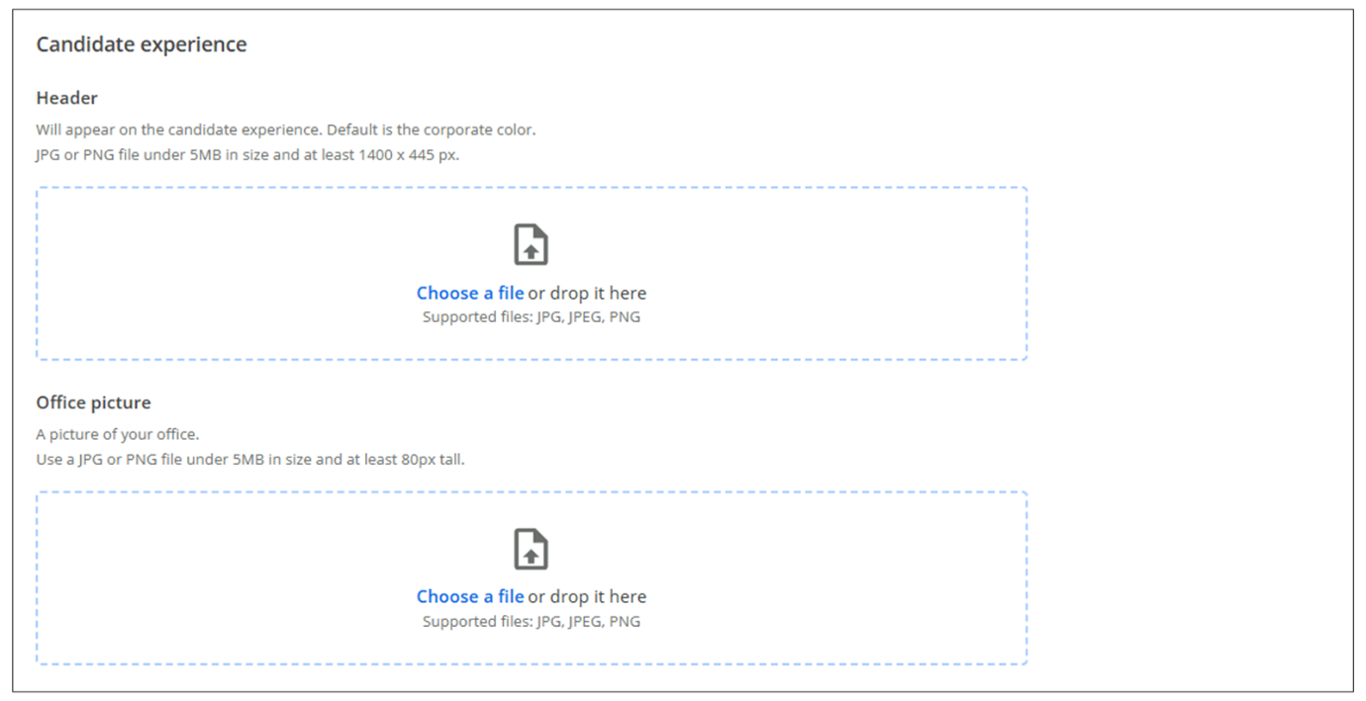
Configure Additional Brands
To add a new brand or edit an existing brand:
Steps
- Navigate to Settings.
- In the Configuration section, select Brands.
- To add a new brand, select Add brand. To edit an existing brand, select the pencil icon of the brand you'd like to edit.
- From here, you can set the Brand's name, logo, and colors and configure how it's presented on job ads and the Candidate Portal.
  - Add the brand's name and choose a corporate color. This color can be used across various parts of the candidate experience (e.g., buttons in the candidate application).
  - Select Check color contrast to evaluate the contrast ratio between foreground text and background colors. This ensures compliance with accessibility guidelines for readability and accessibility.
  - Next, upload the brand's logo, in .png or .jpg format. As with your company profile, you can upload two logos: a larger rectangular one (at least 188px wide by 100px tall) for posting jobs, and a smaller square one (300 x 300px) for sharing jobs. In either case, the logo should be less than 5 MB.
- Configure the Brand Career Page.
  - Select a destination for the Show all jobs link on your job ads. The default link points to your main Careers page; if you have a separate Careers page for each brand, add it here.
  - Add a link to each brand's LinkedIn page. This way, jobs posted on LinkedIn can be linked to a specific page. Adding a LinkedIn page is optional.
- Configure the Job ad.
  - Select the color of the main buttons on your job ads. You can use your corporate color (chosen above) or another custom color (select it or enter its hex code).
- For all brands, you can upload a header.
  - At this time, this header appears only at the top of consent requests, which can be triggered from the applicant list for a job.
  - Headers must be in .png, .jpg, or .jpeg format. The file must be under 5MB, and at least 1400px wide by 445px tall.
An example of header configuration and its appearance in a consent request:
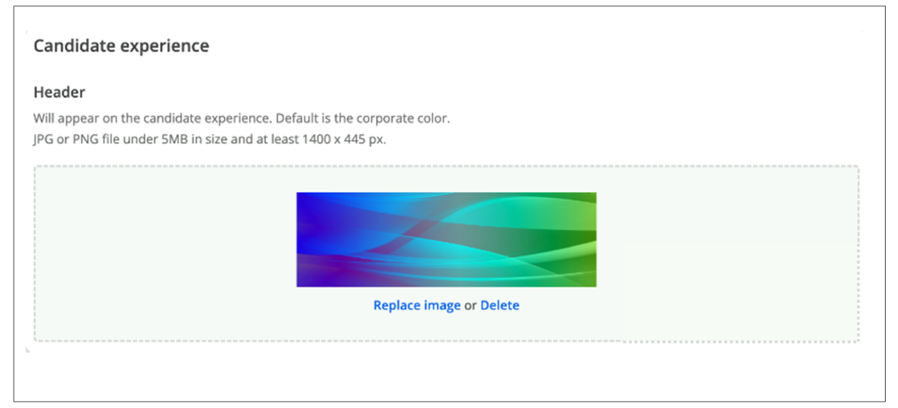
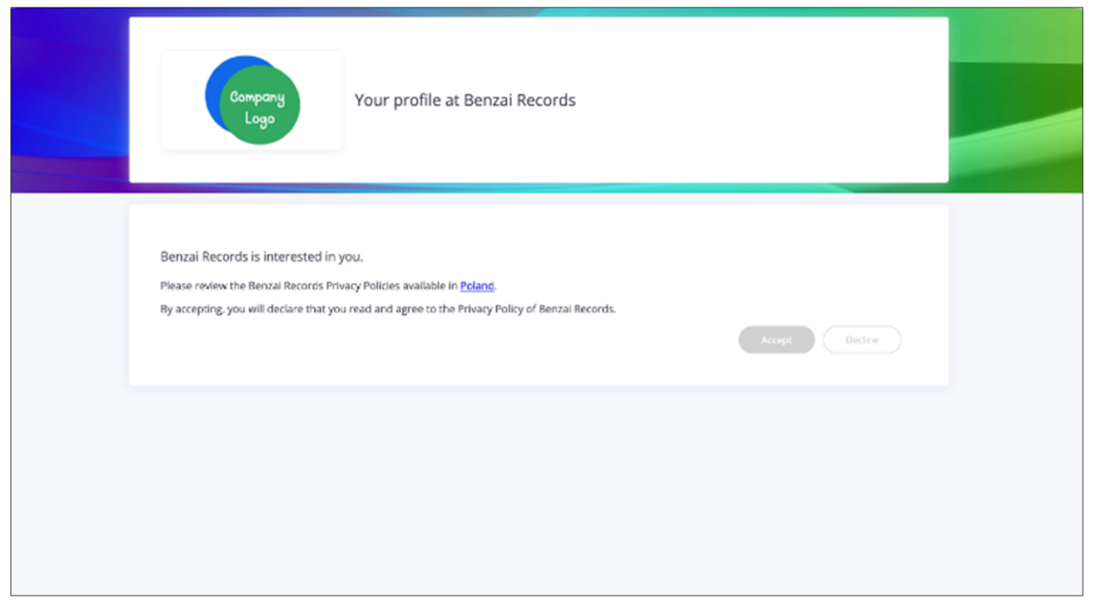
Summary
- Configuring your default brand allows you to customize the look and feel of your job postings and candidate portal to reflect your company's identity.
- Adding additional brands enables you to advertise jobs under different brand identities, catering to specific target audiences or business units.
- Uploading header images and office pictures enhances the candidate portal's visual appeal, creating a more engaging and memorable experience for job seekers.
Building Career Pages
Objective
After completing this lesson, you will be able to customize Career pages using SmartRecruiters Career Page Builder.
Career Pages Overview
SmartRecruiters' Career Pages are multi-device-optimized, localized, and configurable web pages that list your current job openings and allow you to drive candidate traffic, showcase your brand, and give your candidates an unparalleled user experience when expressing interest in your jobs.
Admins can quickly build branded, video-enabled career pages with SmartRecruiters’ Career Page Builder—no design or technical skills required.
The Career Page Builder allows you to:
- Create multiple career pages and target them to a dedicated audience.
- Build global career centers thanks to built-in support for 22 languages.
- ​​C​ustomize and configure the design, images, content, and jobs displayed.
- Give a mobile-optimized experience for candidates using a mobile device.
- Integrate with your corporate website for a consistent candidate navigation experience.
Create a Career Page
Steps
- Select User Menu→Settings.
- In the Career Page Setup section, select Career Pages & Job Ad.
- (Option 1): If this is your first visit to the list, you'll see only the All jobs (default) career page. You can then:
  - Select Edit Settings to update the name, language, and the jobs listed on a career page.
  - Select Edit Content to edit the look and feel of a career page.
- (Option 2): If this is not your first visit, and you want to add a new career page, select Add New to create a new career page.
Note
The default career page is automatically created and its URL cannot be altered. The URL includes your company name as it is entered in SmartRecruiters. While the default language can be modified, other aspects of the default page remain fixed.
Default Career Page Editing
In the Default page configuration tab, you can define which page should be used as the default career page. This gives you greater flexibility in managing your recruitment process.
If the Custom URL option is selected, a required input field will appear for customers to enter their preferred URL.
Once the custom URL is provided, any bookmarks or links to the default career site will automatically redirect to the specified URL.
Note
When the Custom URL option is enabled, the SAP SuccessFactors default SmartRecruiters career site will be deactivated and made non-editable.
You must manually unpublish any custom career pages you wish to make inactive.
Create Additional Career Pages
SmartRecruiters allows you to create additional career pages tailored to specific job categories or departments.
Steps
- Select the + Add new button.
- Fill in the page name and select a default language.
- Define which jobs should be displayed on this page. You can filter jobs based on various criteria such as department, location, ​or ​job level​ or other Org fields​. Multiple filters can be applied to further narrow down the job selection.
- Select Add new at the bottom of the page.
- To delete the career page, select Delete this career page option at the bottom of the Add new Career Page screen.
Changing the name of a career page will also update its URL. Changes made to Career Page settings or design may take up to 10 minutes to appear on the live Career Page.
Customize the Look and Feel of Your Career Page
The Career Page Builder is an interactive editor that allows users to directly add text, images, and styling.
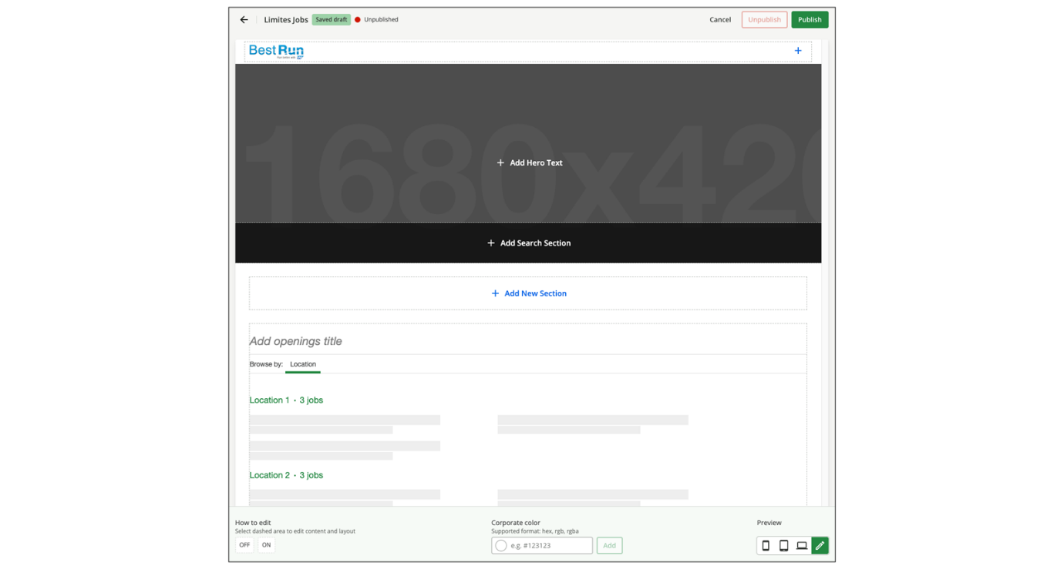
There are four editable sections of a Career Page:
- Header: Add your logo and a Get in Touch button to the header.
- Main Hero: Add an image, video, or text to the main hero section, and add a Search section to let candidates search through the list of jobs on the career page.
- Additional Sections: Add sections to include any other content, like images, text, or another video.
- Job List: Configure the grouping and list type for the jobs list.
Steps
- Header: The Header section contains your logo and a Get in Touch button.
  - Select + on the right side of the header to add the Get in Touch button. Candidates who don't see a job they'd like to apply for in the Career Page's list can use the Get in Touch button to submit their resume and information through the General Application. SmartRecruiters will localize the text of the Get in Touch button in the language set in the Career Page's settings.
  - Select the company logo to edit. By default, the header displays your default company logo, even if you've chosen a specific brand in the Career Page settings.
  - Upload the image using the option in the footer.
- Main Hero
  - Select the Main Hero header to add a title, background image, or video, and a Search section that candidates can use to search through the list of jobs on the Career page.
  - Select the center of the header to add header and subtitle text.
  - Upload or select an image or video from the footer to edit the background image.
- Sections
  - Activate the Job Search bar by selecting the Add Search section. You can enter your own default text here. If not, SmartRecruiters will localize the default Search bar text to the language selected for the Career Page. (Note that by default, the hero's text is centered. You can choose a different alignment from the footer located at the bottom right of the screen.)
  - Select Add New Section and enter more information about your company, perks, values, and anything else you think might drive candidates toward your jobs.
  - Select the image or video icon in the section.
  - Upload the image or add the video's URL in the footer. Each new section can have an image or video.
- Jobs List: The jobs list will display all your jobs or the subset that you've selected in the page settings.
  - Select Add openings to add a custom title to the list. SmartRecruiters will localize the jobs list headers to the language selected in this page settings.
The selection of your Job List Types will determine how jobs display on your Career Page. Three options are available:
  - Grouped View – jobs are grouped by department or location.
  - List View – jobs are displayed in a single, continuous list.
  - Two Column List View – jobs are displayed in a column format, showing the job title and additional information such as location, department, type of employment, or experience level.
When using Grouped View, you can use the dropdown on the left to determine how your jobs display on the page. The available grouping options are Department and Location.
The dropdown on the right lets you provide additional information about the job. The available additional information options are Department, Type of Employment, Experience Level, or None. None will take the place of the selection made in the left dropdown to prevent duplication of information.
For the Single-column and Two-column list options, the values from both dropdowns will be displayed directly below the Job Title.
- Preview
  - Select the preview buttons in the footer on the right to see how the career page will look on different devices: mobile, tablet, and desktop.
  - Select the pencil icon to return to editing mode after previewing the layout.
- Publishing
  - Any newly created career page must be published via the Publish link to reflect the configuration and filters applied. If the new page isn't published (and the indicator turns green) it will redirect to the default career page and all roles will be displayed.
- Application Configuration
In the Application Configuration tab, administrators can customize the published career page with the two settings listed below:
  - Display Similar Jobs : You can show or hide the Similar Jobs section on your job ads by using this setting. If this option is activated, the candidates visiting your job ads will see three similar jobs from ​other ​companies using SmartRecruiters.
  - Display job ad content for unpublished jobs : You can control the visibility of the job ad content for your unpublished/canceled job ads by using this setting.
Note
This checkbox is enabled by default. It means that the general public will be able to see the job description for the unpublished or canceled jobs in case they land on the previously generated public job ad URL.
Watch the video below to gain more knowledge about editing career pages.
This video is for demonstration purposes. Any references made in this video to previous or later videos in this course (including titles, numbers, links, or sequence) may differ from the current course structure. Additionally, some functionalities shown may have evolved over time due to ongoing enhancements or business decisions.
Summary
- You can build branded, multilingual, mobile-optimized career pages and customize header, hero, sections, job list (grouped/list/two-column).
- You can publish pages or redirect to default page.
- Configure settings to hide similar jobs or unpublished or canceled jobs. By default, unpublished or canceled jobs are visible to the public.
n this video we're going to be
looking at how to edit your career page in SmartRecruiters. Admins
have the ability to edit or customize their career page and to get to
your career pages from the settings and admin page. Under Career Page
Setup click Career Pages and Job Ad. Here you'll see a list of all
of your current career pages. There will always be a default
career page and the URL cannot be changed. The name of your
company will be at the end of the URL and it will be entered as
it's entered in smart recruiters. You do have the option to change
the default language for your default career page but everything
else is not editable here. You can also create additional
career pages if you want to have pages that show only specific
jobs. So for example I have a Customer Service Jobs page
here and on this page it would only show jobs that are in the
Customer Service department. To create an additional career page click Add new and then you can name your page. So for this example, I'm going
to be creating a page that only displays jobs in my technology service
department or my IT department. So I'm going to name the page IT
Jobs, I'm going to choose my default language, and then here I'm going
to click Selected and this is where I'm going to decide what jobs are
going to be shown on this page. You'll see various job fields
here you can filter by. I'm going to filter by department
and I'm going to choose tech support. You can have multiple
filters on a page, so maybe if I wanted tech support jobs
at entry level or I only wanted tech support jobs in a certain
location, you can do that. But for right now, I'm going
to just choose the one filter. When you're done, you can click Add New. And now you'll see that this
job page is ready to go. You do have the option of changing
the name of your page later on, but note that whatever
you name your career page is going to be what's added to the
URL. So if you do end up changing the name of this page later
on, it will change the URL. You also have the option to delete
a career page by scrolling to the bottom and clicking Delete this
career page option if you want. I'm going to close this,
and then you can change the look and feel of your
site. So I'm going to click the Edit button
here on my default page. You'll notice as I open my career
page there's various dashed lines. As I click into these this is
showing me the section that I will be editing and it will give me the
editing options here at the bottom. At the top here I have
an option to change my logo and I can upload my logo here. I can also add links to my
header if I'd like so if I wanted to add another link at
the top I would come down and type what I want that link to say,
and then type in the link. When I click Add link it
will add it here at the top. And then I have the option if
I need to remove these just to click on the link and click the
X. I also can edit links if I need to as well. And then you'll notice
the Get in Touch button. The Get in Touch button allows
candidates that aren't ready to apply to a specific job with your
company to still fill out a form and get their contact information
into your ATS as they're interested in your company but not
ready to apply. In SmartRecruiters, this form creates something
called a General Application. Only admins and extended
users or users that are able to see all jobs can
see General Applications. So you'll want to make sure that
if you are using this feature, that you have somebody with the
correct permissions regularly going in and looking for candidates
with those general applications. I can change the color of my button
here if I'd like. So I'm clicking the pencil and I can choose the hex
code here that I want for my color. And then if you don't want to
use the Get in Touch button, you can get rid of it entirely
by clicking the X up here. Next, I have the hero
or header image area. I don't have to have a header
image if I don't want. So if I wanted to remove the entire section,
I could click Remove section. But I'm going to add it back in.
And you'll notice here it does give you a recommended size
for your hero image if you're going to add your own. But down
here you have the option to choose a stock image as well.
You also can have a video play instead of an image, and here is
where you'd put that video link. That middle plus sign is
where you can add your language to be shown
on top of your header. And then you can have
a subheader as well. You have the option here
to change the alignment. Or if you don't want text at all,
you can remove the section entirely. Next, we have our search bar,
and you can change what this says here if you want, so you can
just have it say nothing, or you can say search jobs, and again,
if you want to, you can remove the entire section if you do not
want the search bar available. Then we have an area called sections. So if I click Add a new section,
I'm given the option again to upload a photo, and I can upload my own
or I can use again the stock images that we have here or I can add a
video and then over on this side I can add a title and then whatever
text I need here you can add links you can bold. There's a little more
formatting options in this area and if I want them to swap sides
I can click down here on Article align and I can have them change I
can add multiple section as well if I want to so maybe I want one on
this side but note that on a mobile device, these sections stack.
So if you do have numerous sections before you get to your jobs,
that may cause a lot of scrolling for mobile users. So you want to
choose what sections you add wisely. You can remove a section as well. And then down here is where we're going to look at how our jobs are displayed. So you can change the
text here to whatever you'd like if you'd want.
You just start typing. And there's different ways
you can display your job. You can do the group view and
here you can decide what you want it grouped on by
changing this first drop-down here. So I can either have
it by department or location. You also can have just a single list or you can have a column list. This first block, the longer
block here, is going to be the job title and then you can decide what
to display here for the additional information so this first block
here can either be location or department type of employment
or experience level this is all going to pull from your job ad
and then if you want another additional piece of information you
can choose it here. Have none will show you nothing but then maybe
i want also location and once you're done with your site you can
click Publish and now if I go to my career site you'll see here
what it looks like. Thank you for watching this video on editing
career pages and SmartRecruiters.

Configuring Job Widgets and Job Alerts
Objective
After completing this lesson, you will be able to configure SmartRecruiters Job Widgets and Job Alerts to control branding, filtering, visibility, and sourcing.
Job Widgets
Job widgets are customizable JavaScript snippets that you can drop into your company's website​ or internal site​. Each widget displays a list of jobs, and candidates can click a job to view its ad and apply. Once you've configured the widget, SmartRecruiters will generate the code for you. Just copy this code and ​​add it to your​​​​ company's site.
Admins can:
- Set up multiple job widgets and customize their color.
- Create specific widgets for departments or locations.
- Give each widget a specific source so that you can track candidates who apply to jobs using that widget.
Customize the Job Widget
Steps
- Navigate to Settings→Admin.
- Select Job Widget in the Career Page Setup list.
- Customize the design of the widget:
  - Select columns
  - Choose which jobs to filter (if any)
  - Select the source of the widget
Adding Styling
- Brand your widget by selecting colors for the rows, header, text, and background.
- Select a color using a color picker or by RGB or Hex values.
Customize Columns
By default, the widget will display all active (published) job ads and in the background generate HTML and JavaScript code snippet elements. You can change these values. The widget can display up to 5 column and you can add or remove columns.
- Remove column headers for a cleaner presentation when embedding the widget into your site.
- Select Display ability to filter jobs to let candidates filter the list of jobs on their own.
Filter Jobs
- If you're creating a widget for specific locations or departments, choose them from the Filter Jobs tab. If you just want to display all your active jobs, skip this tab.
Note
If you have the SmartMobility add-on, you can also filter jobs by their visibility and create a job widget that displays your internal job ads.
Types of Job Ads
  - Public job ads only: select if the job widget should display only public ads.
  - Public job ads and internal job ads: select if the job widget should display both public and internal ads.
  - Internal job ads: select if a job widget should display only internal ads.
  - Selecting either of the latter two options will generate a security token, which will be added to the widget code to allow internal ads to show in the widget's list of jobs.
Set Source
- By default, any candidate who applies to a job found through your widget will have a source of job widget.
If you only plan to use one widget, you can keep this source's name, or edit it.
If you're creating multiple widgets and would like to track candidates from each widget separately, give each widget a different source name.
Get Widget Code
- While you're on the Job Widget page, click Get Code at any time, on any tab, to get the code for the currently displayed settings ​​in a small​​ JavaScript snippet. Paste this snippet into your site to produce the widget as displayed in theLive Preview. You can also provide this code to your design team to embed the widget on your external career site.
Caution
The code is not stored in SmartRecruiters after you leave the page, so it's essential to save it in a safe place.
Note
Javascript of the job widget can be updated with new versions. To update your job widget code, generate a new code from the job widget page under Settings→Admin.
Watch this video to learn more about job widgets.
This video is for demonstration purposes. Any references made in this video to previous or later videos in this course (including titles, numbers, links, or sequence) may differ from the current course structure. Additionally, some functionalities shown may have evolved over time due to ongoing enhancements or business decisions.
Job Alerts
Create a job alert to help candidates set up automatic monitoring for new jobs. Job alerts can be personalized for key terms in the job's title - using the Keyword field. Note that this does not search the job description. When you post a job that matches, SmartRecruiters will send an email to candidates to let them know.
You can add a job alert widget as a button on any webpage using a pregenerated HTML and JavaScript code snippet. Though you won't need assistance creating the widget, you may need technical support to add the snippet to your site.
Timing
Once someone sets up a job alert, SmartRecruiters will send them the first alert email 24 hours later (assuming there's at least one job that matches), at the same time that they set up the alert. We'll look once a day for matching jobs.
So, if a candidate​s​ sets a job alert up at 5:35 PM one day, they'll receive an email at 5:35 PM every day, whenever a matching job that day is found.
Note
Since SmartRecruiters runs once a day, if someone posts ​a ​matching job after the search is run, that candidate may not receive the email until the next day.
Internal and Public Job Alerts
By default, job alerts promote your public jobs. Anyone who applies for a job via the email alert they receive will be marked as an external candidate.
You can also create a job alerts widget that promotes both internal and public jobs. There is an option during setup that configures the widget to retrieve internal jobs and send them to candidates who sign up via this widget.​ This can be added to internally hosted sites to encourage internal applications.
Note
Be careful not to add an internal ​j​ob alerts widget to a publicly accessible site. Anyone who signs up for alerts via that widget and applies to a job from the emails received will be marked with the Employee tag, even if they are not one of your employees.
Configure Job Alert Widget
Steps
- Navigate to Settings.
- Select Job Alerts in the Career Page Setup list.
- Select the toggle in the top right corner to activate Job Alerts.
- Choose the language settings for the alert configuration window.
- Select one, all, or none of the job fields to help candidates filter jobs by business function, full/part-time, experience level, or location. Each field and its values are identical to the ones on the Details step of the Job Posting Wizard.
- Customize how the button will look on your site. The text isn't editable, but you can change the button's color to match your brand, and remove the SmartRecruiters logo.
- By default, job alerts will include only public jobs. If you'd like to create a job widget for internal jobs, check the option in Configure Internal Mobility options.
- Select Grab Code to generate the HTML for the button and the JavaScript code for the widget itself.
Watch this video for more information on configuring job alert widgets.
This video is for demonstration purposes. Any references made in this video to previous or later videos in this course (including titles, numbers, links, or sequence) may differ from the current course structure. Additionally, some functionalities shown may have evolved over time due to ongoing enhancements or business decisions.
Summary
- Job widgets are customizable JavaScript snippets that list jobs on your site; you can configure columns (up to 5), filters (for example, department, location, visibility), branding, and a source for candidate tracking, then generate and embed the code. Selecting internal or both internal/public ads adds a security token to the widget code.
- Widgets default to showing all active jobs and a default job widget source; use distinct source names to track candidates per widget. Generated code is not stored in SmartRecruiters—copy and save it, and regenerate code when widget versions are updated.
- Job alerts let candidates subscribe based on keywords in the job title (not description). Alerts run once daily, with the first email 24 hours after setup at the same time of day that the alert was set up. You can configure language, filter fields, button style, and internal mobility; do not place internal alert widgets on public sites to avoid mistagging non-employees as Employee.
Hi, in this video we're going to
be looking at how to use the job widget feature in SmartRecruiters.
If your company has a career site outside of SmartRecruiters but
would like to have a way to post jobs within SmartRecruiters on a page
on that career site you can do that using a job widget. So to get to
your job widget on the Settings and Admin page under Career Page Setup
you're going to click Job widget. So like I mentioned if my company
has a career site and they want to show SmartRecruiters jobs on
that site they can embed a widget onto a page and the widget will
look something like this. Now in a minute I'll show you you can edit
the colors and the columns but this is what would show up on that
page is this preview area here so the first thing we want to do is
change the colors so here you can choose if you have the hex codes
for your corporate colors you can do that here. I'm just going to use
the color picker in this instance so I'll hover. I want that blue
color maybe I want my column to be a lighter blue and then I can
change my text color on my header. I can change the row text color here
and then the even and odd colors for the background I can change
here as well if I want. I can also change the width of my widget so
I can have it automatically adjust to the site or if I want it to
be a specific size and pixels. I can put that here. We usually
recommend that you leave it automatic but if your design team
needs it to be a specific pixel width and height,
you can do that here. And then you can decide
how many jobs it's going to show. You can have it
display all your active jobs or you can limit
it to a number of jobs. Next we're going to select what
columns we want to display. So by default it will always
show the job title and location, but I can also have it display department or the date, and if I
choose to show the published date here I can choose the
way that it is displayed. I can also choose to remove
the header if it's not needed, and I can also add a filter
area to this job widget as well so candidates can use
this to filter and search jobs. Next I want to decide what jobs are going to be displayed on this widget. So right now as I have it, all jobs will be displayed here, all active jobs. But you can create multiple
widgets for multiple pages. So if you have a page that's only
showing customer service jobs or a page that will only show
retail jobs, you can create multiple widgets to suit
your needs. And here under Department, if I wanted to have
just retail jobs, I click Retail and it will show it here. You also can show just locations
or by the language of the job ad as well. You also can choose
the type of job ad that's going to display. So I can have just
my public jobs shown on this widget or if I have internal jobs
I can do that as well. So I can have both public and internal
jobs in one widget. Or if I have a company internet or a internal
site and I want to put a widget there, I can have it show only
internal job ads if I'd like. And finally you're going
to set your source. So if a candidate clicks on a
job through a widget you're going to want that source
tracked in your ATS. So here you can decide what
you want as your source type and then whatever you want
your source to be here. So JobWidget is defaulted, but maybe
if this was customer service you can choose your source here. If you don't know how to
create custom sources you can refer to our tutorial on how
to do that in our university. And then once you've set your
source you can grab your code by clicking the Grab Code button. And
here is where you're going to copy and paste this javascript and
this is what you will be giving to your design team in order for them
to embed the widget on your page. You can click Copy to
copy it to your clipboard. But note that once you leave
the widget page in SmartRecruiters, this code is not
stored anywhere so it will be gone. So we always recommend copying
it and keeping it in a notepad or a file somewhere in case
you need to refer back to it. Hi, in this video we're going
to be looking at how to set up the job alert widget in
SmartRecruiters. You have the ability to configure a job alert widget
that can be placed on your career site that will allow
candidates to be notified when new jobs are posted to your
site that fit their interests. To set up the job alert
widget, on the Settings and Admin page, under Career
Page Setup, click Job Alerts. You do have the option to disable
the job alerts feature just by clicking this toggle here, but if
you do want to use this feature, there are some decisions you have
to make as far as configuration. The first is what language the job
alert widget is going to be in. We recommend that you keep the
language set to browser's language, and that way the job alert
widget will display in whatever the language is that's set by
the candidate on their browser. But if you want to hard code a specific language, you can choose
from the list here. Next you want to choose
what fields are going to be available for the candidate
to fill out when they're putting their information
into the job alert widget. If I click preview, you'll
see an example of what the candidate will see when
they're filling out the widget. First name, last name, email address,
and keyword are all standard, but you have the option of
what you want to include as far as location, level experience,
function, and type of employment. To choose which fields you want
displayed, click on the fields dropdown, and you can choose which
ones you want displayed or not. If you don't want any of them
displayed you can click all and now if I go to Preview you'll see
that those fields are now gone. Then you're going to
customize what the job alert widget button looks like.
Down in the preview box is a preview of what it will
look like on your site. You have the option to change
the icon so you can have it either without the icon or with
the smart recruiters icon and then you can change the button
color either by entering a specific hex code that you have
or using the color picker here. Finally, you can decide
whether you want internal jobs to also be included in the
job alert notifications. And if you do, you can
click this button here. Once you've made your changes,
you're going to want to click grab code and give this code both step
one and step two to your web team so they can embed it onto your career
site. Thank you for watching this video on how to configure the job
alert widget in SmartRecruiters. Thank you.

